Project Title
Mini Search Engine
Project Report submitted for the partial fulfilment of grade for the course

Data Structures and Algorithms -3 (25CS2103E)
in

A.Y. 2026-2027

Submitted by
K. GAYATHRI SRIVALLI(2520080010)
M. HRUTHIKA(2520090002)

Team Number: 18
Section: 12

Under the guidance of

Ms. Chandusha Kanda

Asst. Prof, CS&IT
Hyderabad-500090, Telangana, India.

K L (Deemed to be) University
DEPARTMENT OF COMPUTER SCIENCE ENGINEERING / COMPUTER SCIENCE AND INFORMATION TECHNOLOGY/ARTIFICIAL INTELLIGENCE & DATA SCIENCE



DECLARATION

The Mini Project Report entitled Mini Search Engine is a record of Bonafide work of K. GAYATHRI SRIVALLI(2520080010), M. HRUTHIKA(2520090002)submitted in partial fulfillment for the award of B. Tech in Computer Science and Engineering/Computer Science and Information Technology/ Artifical Intelligence & data Science to the K L University. The results embodied in this report have not been copied from any other departments/University/Institute.

K. GAYATHR SRIVALLI(2520080010)
M. HRUTHIKA(2520090002)

K L (Deemed to be) University
DEPARTMENT OF COMPUTER SCIENCE AND INFORMATION TECHNOLOGY AND ARITIFICAL INTELLIGENCE & DATA SCIENCE
CERTIFICATE

This is to certify that the mini project based report entitled Mini Search Engine is a bonafide work done and submitted by GAYATHRI SRIVALLI(2520080010), M. HRUTHIKA(2520090002 )in partial fulfillment of the requirements for the award of the degree of BACHELOR OF TECHNOLOGY in Department of Computer Science Engineering/ Computer Science and Information Technology/Artificial Intelligence & Data Science, K L (Deemed to be University), during the academic year 2026-2027.

Signature of the Supervisor

Signature of the HOD Signature of the External Examiner

ACKNOWLEDGEMENT

The success in this project would not have been possible but for the timely help and guidance rendered by many people. Our wish to express my sincere thanks to all those who has assisted us in one way or the other for the completion of my project.

Our greatest appreciation to my guide, <<Guide Name>>, <<Designation>>, <Department>> which cannot be expressed in words for his/her tremendous support, encouragement and guidance for this project.

We express our gratitude to Dr. P.Venkateshwar Rao (CSE)/Dr. Khaja Shareef (CSIT)/ Dr. Sreenath Itikela (AI&DS), Head of the Department for Computer Science Engineering/ Department for Computer Science and Information Technology/Department of Artificial Intelligence and Data Science for providing us with adequate facilities, ways and means by which we are able to complete this project-based Lab.

We thank all the members of teaching and non-teaching staff members, and also who have assisted me directly or indirectly for successful completion of this project. Finally, I sincerely thank my parents, friends and classmates for their kind help and cooperation during my work.

K. GAYATHRI SRIVALLI(2520080010),
M. HRUTHIKA(2520090002)

TABLE OF CONTENTS

S.No. | Contents | Page no.
1. | Abstract
2. | Introduction
3. | Literature survey
4. | Problem Statement and Objectives
5. | Hardware and Software requirements
6. | Implementation
7. | Results & Discussion
8. | Conclusion & Future Scope
9. | References

1.ABSTRACT

The Mini Search Engine is a data-structure and algorithm-based application designed to search and retrieve relevant information from a collection of documents. The system accepts a user query, processes the query, searches through an indexed collection of documents, and displays the most relevant results.
The project demonstrates the application of advanced data structures and string-processing algorithms for efficient searching. An inverted index is used to map words to the documents in which they occur, while data structures such as hash tables, tries and heaps can be used to improve searching, indexing and result ranking. String-matching techniques such as KMP or Rabin-Karp can be used for efficient pattern searching. Dynamic programming techniques can also be applied for operations such as approximate or spelling-based matching.
The main objective of the project is to demonstrate how appropriate data structures and algorithms can significantly improve the efficiency of information retrieval compared with a simple sequential search.
Team Name: INNOTECH
Team Members:
- GAYATHRI SRIVALLI(2520080010),
- M. HRUTHIKA(2520090002)

- INTRODUCTION

2.1 Introduction
Search engines are systems that allow users to find relevant information from a large collection of data. A search engine generally receives a query from the user, processes the query, searches an indexed collection of documents and presents the most relevant results.
A basic search system can scan every document sequentially for every query. However, this approach becomes inefficient as the number of documents increases. Data structures and algorithms can be used to reduce the search time and improve the efficiency of the system.
The proposed Mini Search Engine focuses on implementing the fundamental concepts of Data Structures and Algorithms in an information-retrieval application. The system maintains an index of words and their corresponding documents. When a user enters a query, the system searches the index rather than scanning every document from the beginning.
2.2 Motivation
The motivation for this project is to understand how theoretical DSA concepts are applied to a practical problem.
A search engine provides a suitable application for studying:
- Hashing
- Inverted indexing
- String matching
- Trie-based searching
- Searching and sorting
- Priority queues/heaps
- Dynamic programming
- Time and space complexity
- Algorithm selection
2.3 Project Overview
The basic workflow is:
Documents → Text Processing → Index Creation → User Query → Query Processing → Search → Ranking → Results
For example:
Suppose the database contains:
- AI.txt
- MachineLearning.txt
- DataScience.txt
If the user searches:
machine learning
the search engine identifies documents containing these terms and returns the most relevant documents.

- LITERATURE SURVEY
S.No. | Existing Approach | Technique Used | Limitation
1 | Sequential document search | Linear search | Slow for large collections
2 | Keyword-based search | Keyword matching | Limited ranking
3 | Inverted-index search | Hashing/Indexing | Requires index construction
4 | Trie-based search | Trie | Requires additional memory
5 | Pattern matching | KMP/Rabin-Karp | Mainly suitable for exact patterns
6 | Ranked retrieval | Heap/Priority Queue | Ranking depends on scoring method
Several information retrieval systems use indexing techniques to efficiently locate documents containing specific terms. Traditional sequential searching examines documents one by one, resulting in higher search time for large datasets. Inverted indexing improves this process by maintaining a mapping between terms and the documents containing those terms.
String matching algorithms such as Knuth-Morris-Pratt (KMP) and Rabin-Karp provide efficient methods for locating patterns within text. Trie data structures can further support prefix-based searching and autocomplete functionality.
Ranking mechanisms can be implemented using priority queues or heaps to efficiently select the top results. These approaches demonstrate how suitable data structures and algorithms can improve the performance of a search system.

Research Gap
Most basic search implementations focus mainly on functionality and do not sufficiently demonstrate the underlying DSA concepts. Therefore, this project focuses on building a small-scale search engine where data structures, string algorithms and algorithmic complexity are explicitly considered during implementation.

- Problem Statement and Objectives

Problem Statement
Traditional sequential searching through multiple documents is inefficient, making it difficult to retrieve relevant information quickly as the document collection grows.
Problem Description
A basic search system may scan each document repeatedly for every query, resulting in higher search time. The project aims to develop an efficient search engine using appropriate data structures and algorithms for faster document retrieval.
Objectives
Identify the Project's Purpose:
The project is initiated to demonstrate how Data Structures and Algorithms can be applied to efficiently search and retrieve information from a collection of documents.
Objectives of the Project:
- To develop a functional Mini Search Engine for searching a collection of documents.
- To implement an efficient document indexing mechanism for faster retrieval.
- To apply appropriate string-searching and pattern-matching algorithms.
- To use suitable data structures such as hash tables, Trie and priority queues/heaps where applicable.
- To rank and display relevant search results efficiently.
- To analyze the time and space complexity of the implemented algorithms.
- To demonstrate the practical application of DSA concepts to a real-world search problem.

- HARDWARE AND SOFTWARE REQUIREMENTS
Software Requirements:
- FRONTEND: HTML+CSS+JAVASCRIPT
- BACKEND: JAVA
- IDE/CODE EDITOR: VSCODE
- VERSION CONTROL: GIT/GITHUB

- IMPLEMENTATION

Module 1: Text Preprocessing
This module converts the document text into searchable words by converting it to lowercase and removing unnecessary characters.
import re

def preprocess(text):
text = text.lower()
text = re.sub(r'[^a-z0-9\s]', '', text)
words = text.split()
return words
DSA concept: String processing and arrays/lists.

Module 2: Inverted Index Construction
This module creates an inverted index that maps each word to the documents in which it occurs.
from collections import defaultdict

def build_index(documents):
index = defaultdict(set)

for doc_id, text in documents.items():
words = preprocess(text)

for word in words:
index[word].add(doc_id)

return index
Example:
machine → {D1, D2}
learning → {D1, D3}
data → {D2}
DSA concept: Hashing / Hash Table and Set.

Module 3: Query Search
This module takes the user's query and searches the inverted index to find matching documents.
def search(query, index):
query_words = preprocess(query)

if not query_words:
return set()

results = index.get(query_words[0], set()).copy()

for word in query_words[1:]:
results &= index.get(word, set())

return results
For example:
Query: machine learning

Result:
D1, D2
DSA concept: Hash-table lookup and set operations.

Module 4: Result Ranking
This module ranks the matching documents according to how frequently the query words occur in each document.
def rank_results(query, documents, matched_docs):
query_words = preprocess(query)
scores = {}

for doc_id in matched_docs:
words = preprocess(documents[doc_id])

score = 0
for word in query_words:
score += words.count(word)

scores[doc_id] = score

return sorted(
scores.items(),
key=lambda x: x[1],
reverse=True
)
DSA concept: Searching, sorting and ranking.

Module | Main Function | DSA Concept
1. Text Preprocessing | Cleans and tokenizes text | Strings, Lists
2. Inverted Index | Maps words to documents | Hash Table, Set
3. Query Search | Retrieves matching documents | Hashing, Set Operations
4. Result Ranking | Orders relevant documents | Searching, Sorting

7.RESULTS & DISCUSSION

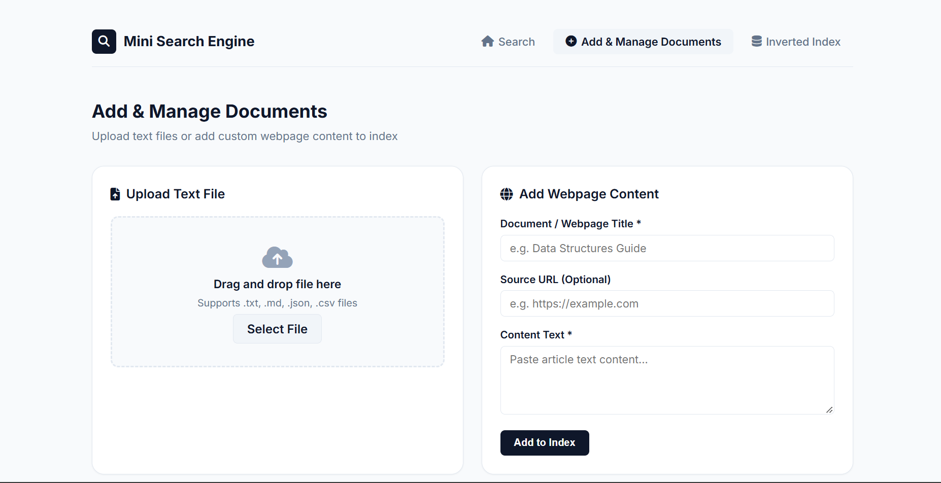

- CONCLUSION & FUTURE SCOPE
Conclusion
The Mini Search Engine successfully demonstrates the practical application of Data Structures and Algorithms for efficient document searching and retrieval. The project achieves its objectives by indexing documents, processing user queries, retrieving matching documents, and ranking relevant results. The use of suitable data structures and searching techniques reduces unnecessary searching and improves the overall efficiency of the system. Thus, the project provides a practical understanding of how DSA concepts can be applied to a real-world search problem.
Future Scope:
Near-Term Enhancements:
- Add autocomplete using a Trie data structure.
- Implement spell correction for incorrect search queries.
- Improve the result-ranking mechanism.
Medium-Term Enhancements:
- Add TF-IDF based ranking for better relevance.
- Support searching across larger document collections.
- Add support for PDF and other document formats.
Long-Term Enhancements:
- Implement semantic search.
- Develop a web crawler to automatically collect documents.
- Introduce machine-learning-based ranking for more personalized and accurate search results.

- REFERENCES

- Manning, C. D., Raghavan, P., & Schütze, H. – Introduction to Information Retrieval, Stanford University.
https://nlp.stanford.edu/IR-book/
- Elasticsearch – Full-Text Search Documentation.
https://www.elastic.co/docs/solutions/search/full-text
- SQLite – FTS5 Full-Text Search Extension.
https://www.sqlite.org/fts5.html
- Reingold, E. M., Urban, K. J., & Gries, D. – K-M-P String Matching Revisited.
KMP String Matching Research Paper
- Elasticsearch – How Full-Text Search Works.
https://www.elastic.co/docs/solutions/search/full-text/how-full-text-works

